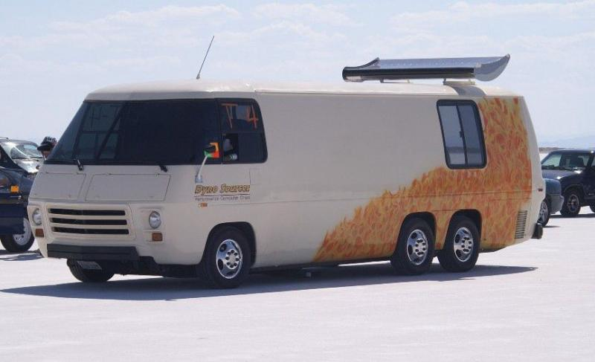

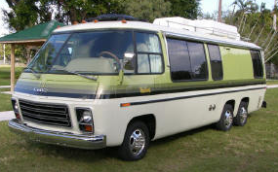
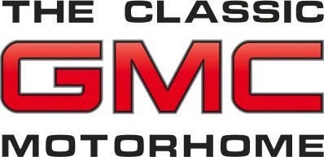

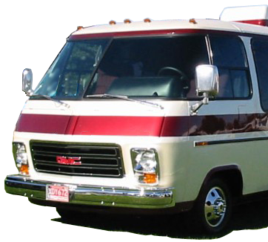

ONLINE INFORMATION

http://wiki.gmnext.com/wiki/index.php/The_GMC_MotorHome - This site features an excellent document on the history and development of the coach.

www.gmcers.org - Go here for a general overview of the GMC and it’s cultic owners.

www.gmcmi.com - The web site of the largest GMC club with members from all over the globe.

www.gmcmhregistry.com - Owners register their coaches here; also of great interest is the trivia page with ownership map broken down by state or province.

http://www.gmcmhphotos.com - Owners post some of their favorite photos showing work done and places visited.

GREETINGS

Thanks for showing interest in my GMC Motorhome. You’re not the only inquisitive person that’s wondered about this timeless vehicle.

Feel free to take this brochure and read a little more about this unique coach. That’s what this document is all about — introducing you the classic, GMC Motorhome. So, turn the page and read about the only, commercially successful motorhome designed and built by General Motors to be just that, a Class A motorhome a that doesn’t look like a box or drive like a truck. It’s the show place that goes places.

PARTICULARS

Chassis: Built by GMC in Pontiac, Michigan

Body: Aluminum and fiberglass skin bonded to aluminum stringers

Year: 1978

Model: Royale by Coachman Industries

Length: 26 feet

Engine: Oldsmobile 403-cubic-inch V-8 with 4-barrel QuadraJet carburetor

Transmission: FWD 3-speed automatic

Suspension: 6-wheel, independent, front torsion bars, rear tandems (adjustable height)

Fuel capacity: Two, 25 gallon tanks

Economy: 8 to 10 mpg

Sleeps: Up to four adults and two children

Bath: Rear with tub, shower, sink and toilet

Kitchen: Two-burner gas stove, convection microwave, gas/electric refrigerator/freezer

Generator: 6,000 watt by Onan

Dyno Sources’ land speed record holder

A restored unit that looks factory fresh
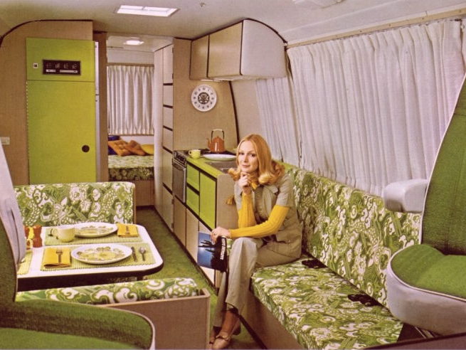
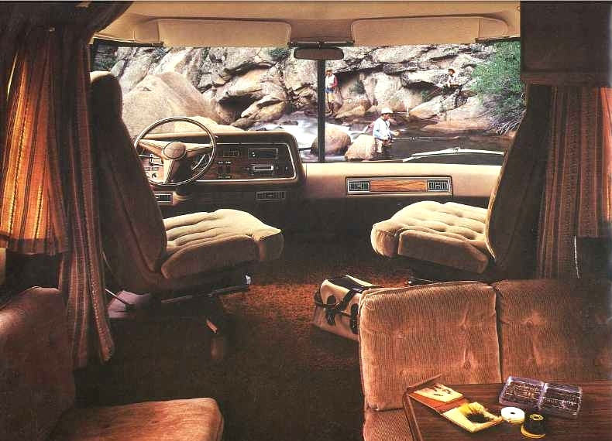
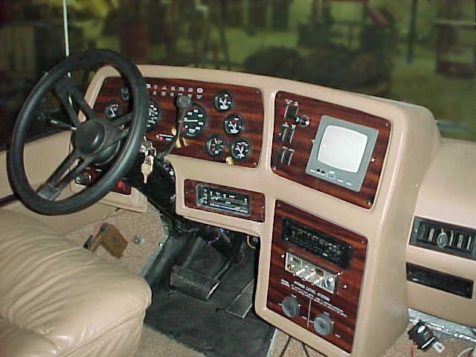
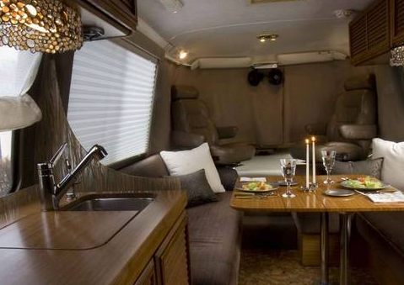
THE INSIDE STORY
The GMC Motorhome is the only motorhome that was designed and built by an automotive manufacturer. It was also unique in that it was conceived to be just that, a motorhome. As a result, it isn’t a box on a truck frame with furniture inside.
It’s the ideal unit. The conceptual design had the following criteria:
a low floor for easy entry and exit by occupants
plenty of headroom for the average adult
a low center of gravity for better handling
the ground clearance a real outdoor vehicle needs
a low roofline for maximum clearance
It was designed around the paired and proven V-8 front-wheel-drive engine and transmission of the 1970s Olds Toronado and Cadillac Eldorado. With all the machinery up front, the rear suspension didn’t need a set of conventional axles running side to side. Simple support arms for the tandem rear wheels were designed to be mounted to the outside of the specially engineered chassis.
Above the chassis is a complete cage of heavy gauge aluminum ribs and stringers. On top of this substructure are bonded skin panels not unlike that of today’s aircraft. The roof and upper side panels are mirror-smooth aluminum while the lower skin panels, nose and rear sections are molded fiberglass.
THEN AND NOW
The GMC Motorhome began selling with the 1973 model year. Through the years several changes and enhancements were made based on the principles of the original design. Probably the biggest change was from the original 455 cubic-inch engine to the 403 yielding a slight loss in horsepower. Both were built by Oldsmobile. Manufacturing continued until 1978 when a variety of circumstances brought an end to productioin.
The story doesn’t end there, however. Today there are more than 8,000 units still on the road. Some have been well maintained while others have suffered from neglect. Some have been restored and others have been renovated.
A healthy channel of dedicated vendors helps keep these coaches running and providing their owners with a high level of support. Enthusiastic owners are members of a bevy of clubs that are fully recognized by Family Motor Coach Association or are active participants in an online forum.

Timeless design and quality built in

New dash by Custom Instrument Panels

The original dash from a 1978 brochure

Looking forward: A renovated interior

An original interior from a 1973 brochure

